Jadavpur Central Road

Instrumentation Study Centre
50 B Central Road, Jadavpur, Kolkata – 700 032
Web : www.instrumenttaionstudycentre.org , Ph: 9821762415

____________________________________________________
To
.........................................
........................................
........................................
.......................................
Dear Sir/Madam,
I am sending you this soft copy which contains the details of one experiment on Light Emitting Diode for children. I am sending this with the expectation that you will spend a little time with any child you know to show the way LEDs are working and also some basic ideas of electronics and instrumentation. You can collect a few LEDs from the local market. These are not expensive at all. If you desire you may also contact us. We will arrange and send a few LEDs and other components which are required for this experiment. You need not pay for that. We can also send a brief study material including the working principle of LEDs and its different applications. I think, in coming days the use of LEDs will be a major breakthrough in lighting technology.. Definitely it will be colourful, decorative, power saving and long lasting. It is also a good idea to start the study of electronics with LEDs for the children.
In our centre we devise many such experiments suitable for the students at different levels. We will send the instruction sheet along with the components needed to do the experiments. The present one is designed for the juniors who are not at all familiar with electronics. I hope this will help them to grow their interest in this field. Other experiments are suitable for the seniors and have sufficient potential for commercial applications.
Our centre, since its inception is working with the idea of encouraging the young students to grow their interest in electronics and instrumentation which will be useful for all of us. You may also visit our website, www.instrumentationstudy.org to see the activities of our centre.
Apart from the present work some other works like solar cell, photodiode, optical fibre, remote control of electronic toys, electromagnet, mobile charger using mechanical energy by applying dynamo principle, measurement and control of light and temperature, will also be enjoyable for children. They will also like our presentation of different discoveries that have changed our ideas about this world.
In any case to execute this work successfully, if needed, please contact us and we will try to help you.
Your remarks on and cooperation in our work are welcome and will definitely be appreciated.
Best wishes,
N .B . Manik

Basic Experimental Techniques for developing Technical Skill of the Children

(Through Picture)

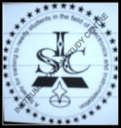

Family project to work on together

Experiment: Light Emitting Diode

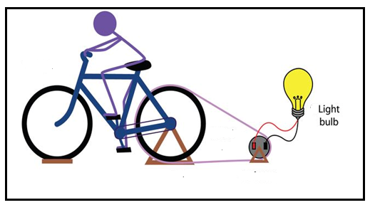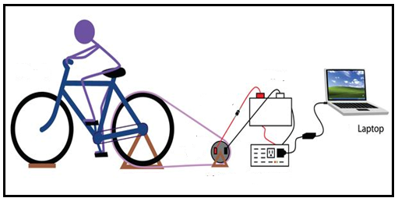

The present write up contains one experiment out of around 500 experiments from the junior section of

Instrumentation Study Centre
50B, Central Road
Kolkata–700 032
Ph: 9831762415
Web: www.instrumentationstudy.org

Designed by
Dr. N. B. Manik , Associate Professor, Department of Physics, Jadavpur University, Kolkata -32
Web: www.nbmanik.in

A Few Words
Like me, I believe that everyone, starting from the kids to senior retired persons of different sectors will appreciate the importance of developing technical skill of the students from their primary level. Development of instruments means precise application of our knowledge to take command on our nature and of course to develop a comfortable society with greater economic growth to make life easy, smooth, stable and secured. Without the progress in this field development of the society will definitely be hampered. Practice of instrumentation is also a form to express our intellect. It may also be a good hobby to pass our time joyfully irrespective of our age, gender and education. Research, development, maintenance and other issues related to instruments play an important role in the commercial market and thereby control our daily life. Its importance in personal to social life, related economical aspects may also be relevant for discussions to grow interest among the students. It is also challenging, even to a policy maker, to formulate the suitable policy to face this technical world along with its emotional counterpart. Beyond all these, instrumentation is also a method to acquire and verify our knowledge. Scientific knowledge should not be verified unless proper instrumentation is developed. As mentioned, development of instruments is a measure to apply our knowledge and skill in a precise way. Precise knowledge is useful to resolve different doubts to make the mind free and relax.
Different ways to spread technical education to diverse people of our community is essential. Along with the colleges and universities where students are served, some different approaches are also important in order to reach the common people. Considering all the above aspects once I tried to set up a small training centre where some needy students can get scope to nurture different ideas as well as there will be also a scope to exchange views and share ideas with experienced persons to develop general awareness among the common people in this field. One may find its aim, objectives and mode of function from our website.
For this centre I have organized some designs on different areas of instrumentation. This present write up has come as a course material for the training section of the young children of our centre. This note mainly contains basic ideas of the experiments designed by us for the technical skill developments of the kids. From these course material one may get some ideas about the activities of our centre. The selection of the problems for the training course of the children are important. It will be the tusk of the seniors to design the problem in such a way so that it will be helpful to give them fun as well as it will relate many other issues of their future course. I have tried to pay attention in this regard. I hope these experiments will also grow curiosity of the children. Apart from the training purposes, some of these designs may be used for the commercial purposes. Its different applications may be highlighted.
Before I conclude I acknowledge the help and cooperation I have received from the members of this centre during this work. We hope our present attempt will be helpful for the young students. I also hope you will enjoy this.

Kolkata, Dated: 09.10.2014 N. B. Manik

_____________________________________________________________________________________________ Issuing certificate of achievements from our centre : Anyone can do these works with a little effort with their children. Sometimes we call these projects as family project which may be carried out jointly with parents and other senior members of the family. If anyone contacts our centre we will also help. After a scrutiny we will issue a certificate of achievements to the participants. I believe that your kids will be benefited and this experience will be helpful to ignite their insight. _____________________________________________________________________________________________

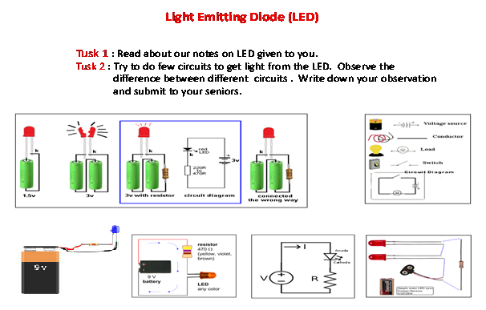
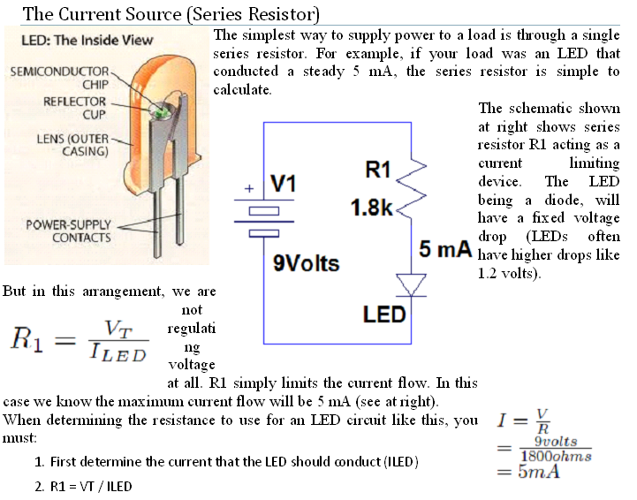
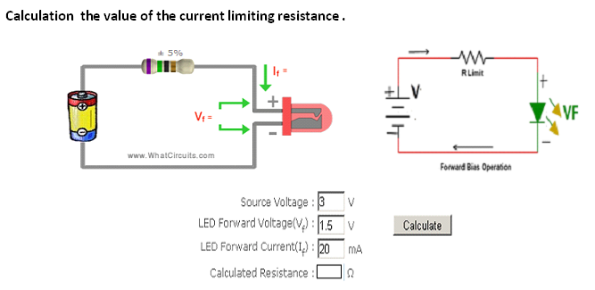

Part of the Reading Materials :

This reading Materials are available on to us

----------------0000---------------
Jadavpur Central Road Registration No: S/2L/4187
Instrumentation Study Centre
A Society for training students to grow interest in Electronics and Instrumentation
50B, Central Road, Jadavpur, Kolkata – 700 032, Ph: 9831762415, web : www.instrumentationstudy.org
._____________________________________________________________________________________________

Respected parents/teachers

On behalf of the Instrumentation Study Centre I would like to inform you that we have arranged a small training programme in the field of electronics and instrumentation for the children of ages around 10 to 18 years (from ~ Class 4 to Class 12 level). The main purpose of our activity is to encourage the young students and also to develop a general awareness in the field of technical education. We work at different levels. The present activity may be considered as the primary step of our other activities which are being done through this centre. One may kindly visit our website www.instrumentationstudy.org to find the objective, specialty, outcome, mode of operation etc. of our centre.

Through our centre we demonstrate different electronic models, working principles of different electronic items etc. By slide presentation we will tell the story of the development of technology, major scientific inventions and also about the inventors. Our trainers help to show some models and generally we take six months time. After six months we arrange for a short test for the students and based on that we issue a certificate. There is no such specific course structure for this programme. We do not claim that it is a big ambitious prorgramme. But we think this will be helpful for the young students. It is our belief and also found through observation that this is inspiring for the young students. We also guess that to have a little exposure in technical field at primary level involving the cooperation of their parents may trigger off their inner thinking to pursue the course in future. One may recollect the story of ‘Apu-Durga’ waiting eagerly for the train in ‘Pather Panchali’. For some of the children it may appear as a discovery. This will be useful for us to remember and guide the children accordingly.

The present activity is helpful to grow interest of young students in this field. So far our activity has been appreciated by many people. For us it is not possible to accommodate everyone. We don’t have sufficient infrastructure. We have decided for an alternative so that different persons from different sectors may participate to extend the present activity according to their choices. This activity does not require much expertise. We request the parents and teachers to encourage their children/students in these activities. As a hobby they can demonstrate some model to their children. We think that in this age of machines every house may be considered as a miniaturized laboratory which is equipped with different electronic gadgets/items. The rejected and obsolete items, modified suitably may be used for the demonstration by the seniors of the family. If anyone contacts our centre, within our capacity we will help to monitor this process by sending our members if required. In some cases, we will provide some components and materials from our centre. After scrutiny we will issue the certificate of achievements of both the teachers and students. The formalities may be discussed if needed. It will be appreciated if you kindly help us to continue this work. Interested persons/teachers may help us to organise course materials for this programme. We hope that any one will realize the importance of technical awareness from the primary level in our country. Considering the vastness of the work our approach may be taken as an initial endeavour in this direction.

Apart from this present activity at the primary level, our other works may also be useful for the seniors.
It will be appreciated if you kindly remark about the activities of our centre.
With best regards,

________
Pallab Das
(on behalf of the President)
Instrumentation Study Centre
Jadavpur Central Road

Instrumentation Study Centre
50 B Central Road, Jadavpur, Kolkata – 700 032
Web : www.instrumenttaionstudycentre.org, Ph: 9831762415

_______________________________________________________________

Format for submission of report

(For issuing a certificate from this centre please fill this form)

Name of the candidate :
Fathers/Mothers name :
Address :
Contact no:
Age :
School
……...……………………………………………………………………………………………………………………………………………..
Work report: (*use separate sheet if needed)
Title of the experiments:
Experiments:
Observation:
Remarks/conclusion:

_{NB:}
General instruction for submission of report : Participants or associated members/persons should submit a brief work report to the society. After a scrutiny certificates of achievements will be issued. There is no such specific format for submission of report. The details of the work done, including the nature of the work, its newness and contribution must be mentioned. Any assistance received from the centre should also be indicated. In the first part of the report details of the participants must be mentioned. In case of experiments the experimental setup, circuitry, results, observation and inference should be mentioned. One may contact for sample report from this centre.

